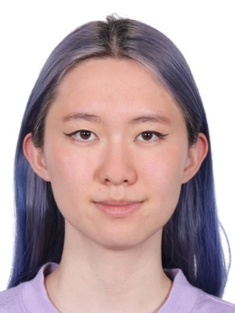
Jennifer Ren

Like most young children, I cycled through a variety of dream careers. Among them were “scientist who discovers new species in the Amazon rainforest” (which I now know is called an ecologist), veterinarian, and neurosurgeon. What was always constant was my curiosity and love for science. Although I no longer wish to explore the Amazon rainforest (my grandmother told me there were poisonous snakes everywhere and nobody was ever going to find my body if I died), I still wish to discover the secrets of the world around me. My dream career today is much less dangerous, but just as exciting. One day, I wish to become a psychiatrist, because, to me, nothing is more fascinating than the human mind.
Being interested in healthcare was nothing new, but growing up in China, mental health wasn’t a concept I was ever introduced to. Even before I knew psychiatry was even an option, I’ve wanted to work in the healthcare industry. I’ve always wanted to help make someone's life just a little bit better, whether it be through just listening to them talk through their problem or actually helping them solve it. When I first got introduced to psychology, I fell in love and knew that was the field I wanted to pursue. As a psychiatrist, I would have better tools to help provide individuals with a safe and supportive place.
I’ve started taking the long journey to achieving my dream of becoming a psychiatrist, from earning a Top 12 spot in the Canadian Biology Olympiad to working as a volunteer with the Care to Live Foundation, which aims to improve access to healthcare for Chinese-Canadians, especially those who struggle with English. Additionally, I work as a Junior Behaviour Interventionist at City Medical Child Development Clinic with children on the autism spectrum, modelling correct social behaviours, teaching a socio-emotional understanding curriculum, and fostering organisational skills. I lead kids through activities that teach and strengthen life skills like creating schedules and cooking.
Although I am primarily interested in the Health Sciences, I also love Creative Writing. Last year, I completed the NaNoWriMo challenge, writing 50,000 words in the month of November, and working on a poetry chapbook that I self-published on Amazon.
This summer, I’ll be working as a counsellor at Camp Summit, an outdoors camp in Squamish, BC., which I have been attending since the summer of Grade 6. Last year, I participated in the Leaders-in-Training program, where I led three different cabins in-conjunction with a Staff member. At camp, I learned both what it meant to be part of a community, as well as what it meant to take responsibility as a leader and team member. I will be working there from the end of June until I head off to Duke University to hopefully pursue a double major in Psychology and Biology, and a minor in Creative Writing.

